Software Requirements Specification

for

AIRLINE RESERVATION SYSTEM

Version 1.0

Prepared by Group - 23

RANASINGHE K.S. 210518H

SAJEENTHIRAN P. 210553J

LIYANAGE P.L.D.S.K. 210344U

PRAVEENASARMA B. 210493A

UDAYANGA H.K.I. 210661M

Department of Computer Science and Engineering

University of Moratuwa

SEPTEMBER 10, 2023

# Table of Contents

Table of Contents ii

Revision History ii

1. Introduction 1

1.1 Purpose 1

1.2 Document Conventions 1

1.3 Intended Audience and Reading Suggestions 1

1.4 Product Scope 1

1.5 References 2

2. Overall Description 2

2.1 Product Perspective 2

2.2 Product Functions 2

2.3 User Classes and Characteristics 3

2.4 Operating Environment 4

2.5 Design and Implementation Constraints 4

2.6 User Documentation 5

3. External Interface Requirements 5

3.1 User Interfaces 5

3.2 Hardware Interfaces 12

3.3 Software Interfaces 12

3.4 Communications Interfaces 13

4. System Features 14

4.1 Flight search 14

4.2 Flight booking 16

4.3 Seat selection……………………………………………………………………………………….17

4.4 Payment…………………………………………………………………………………………….18

4.5 User registration……………………………………………………………………………………19

4.6 Report delay………………………………………………………………………………………..22

4.7 Report generation…………………………………………………………………………………..23

5. Other Nonfunctional Requirements 25

5.1 Performance Requirements 25

5.2 Safety Requirements 26

5.3 Security Requirements 27

5.4 Software Quality Attributes 27

5.5 Business Rules 28

6. Other Requirements 28

Appendix A: Glossary 30

Appendix B: Analysis Models 30

Appendix C: To Be Determined List 31

Revision History

|  |  |  |  |
| --- | --- | --- | --- |
| **Name** | **Date** | **Reason For Changes** | **Version** |
| Group 23 | 10/09/2023 | Initial submission | 1.0 |

# Introduction

## Purpose

This document specifies the software requirements for an Airline Reservation System (ARS). The ARS is a web-based system that allows users to book flights, view flight schedules, and manage their travel reservations. This system provides for the airline administration in flight scheduling, traffic control among others.

## Document Conventions

* The IEEE Software Requirement Specification applies to this document. utilizing bold, italic, and font sizes that adhere to IEEE standard document guidelines.
* The font properties in this document were developed in accordance with IEEE standard document guidelines.

## Intended Audience and Reading Suggestions

* Developers: This document provides the detailed requirements for the Airline Reservation System (ARS) which can be used as a guide to develop the ARS.
* Project Managers: This document will provide the key components and necessary resources of the system which will be helpful in managing the project.
* Marketing Staff: This document provides a description of the features and benefits of the ARS.
* Users: This document provides a description of how to use the ARS. Users will use this document to book flights, view flight schedules, and manage their travel reservations.
* Testers: This document provides the test cases for the ARS. Testers will use this document to test the ARS.
* Documentation Writers: This document provides the information that is needed to write the documentation for the ARS. Documentation Writers will use this document to write the user manual, the installation guide, and the maintenance guide.

## Product Scope

* The Airline Reservation System (ARS) is a web-based system that allows users to book flights, view flight schedules, and manage their travel reservations. The ARS is intended to provide a convenient and efficient way for users to book flights, and to help users save time and money on their travel.
* Benefits expected from this system include user convenience by being able to book flights from anywhere in the world quickly and easily while saving money. There will also be benefits for the system administrators in flight scheduling, managing traffic and gaining efficiencies.
* The goal of this system is to reach millions of users worldwide while being profitable and sustainable.
* Corporate goals of this system include improving customer satisfaction whilst increasing the profitability of the airlines.

## References

* IEEE. IEEE Std 830-1998 IEEE Recommended Practice for Software Requirements Specifications. IEEE Computer Society, 1998.

# Overall Description

## Product Perspective

The Airline Reservation System is a new self-contained product to cater to the needs of B Airways to expand their services due to the new gained popularity of the airlines. Previously there wasn’t any sophisticated system as the airlines was only providing domestic flights. Now the airlines are planning to expand out to provide international flights including popular destinations worldwide. The new system is in place to serve this expansion.

## Product Functions

* Flight search - allows users to search for flights by origin, destination, departure date, and arrival date.
* Flight booking - allows users to book flights. The system must check the availability of seats and prices before booking a flight.
* Seat selection - allows users to select seats for their flights. The system must ensure that the seats that are selected are available.
* Payment - allows users to make payments for their flights. The system should support multiple payment methods.
* User registration and login - allows users to register for the system and login to their accounts.
* Report Delays - system must track flight delays and notify users of any delays that affect their flights.
* Report generation - allows airline administration to generate reports on flight bookings, passenger demographics, and other data.

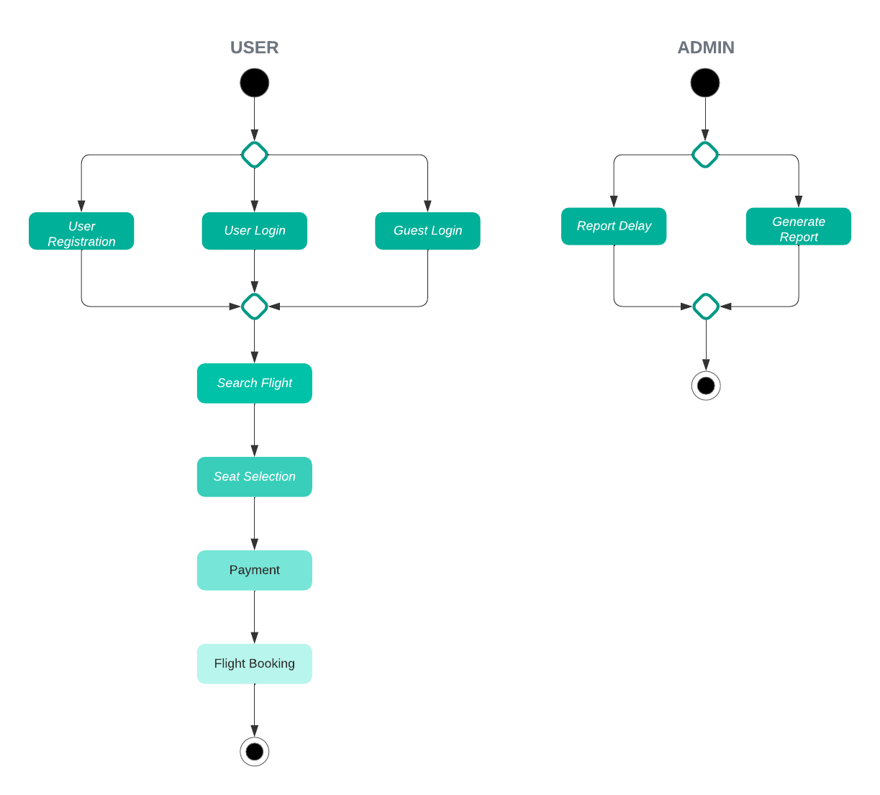

## User Classes and Characteristics

* Passengers: Passengers are the primary users of the system. They will use the system to search for flights, book flights, select seats, and make payments. Passengers are typically not very technical. They should be able to use the system without any difficulty.
* Airline staff: Airline staff will use the system to manage flight schedules, passenger bookings, and other administrative tasks. Airline staff will have a higher level of technical expertise than passengers. They should be able to use the system to perform their tasks efficiently.
* System administrators: System administrators will use the system to manage the system, such as adding new users, flights, destinations and creating new reports, and configuring security settings. System administrators will have the highest level of technical expertise. They should have complete access to the system.

## Operating Environment

Hardware Platform - The system is designed mainly to run on laptop machines with any hardware specifications.

Operating System – The system is mainly designed to operate on windows 11 environment, but it should be able to run and operate on different versions of Windows and Linux operating systems.

Software components and Applications - The system should be able to peacefully coexist with any other software components or applications that may be present in the laptop machines that the system runs on.

* Security Software – The security software installed should coexist with the operation of the system.
* Web browsers – Users may use different kinds of web browsers to access the airplane reservation system and make reservations. The system should be compatible with this.
* System utilities - The system should cooperate with system utilities and tools that operate on the environment such as updates, task manager and system monitoring tools.

## Design and Implementation Constraints

* Corporate or regulatory policies: The system must comply with all applicable corporate and regulatory policies. For example, the system must comply with the airline's privacy policy and the payment card industry data security standards.
* Hardware limitations: The system must be able to run on the hardware that is available to the airline. There may be limitations in memory, the processing power, and the storage capacity.
* Interfaces to other applications: The system must be able to interface with other applications that are used by the airline. Different systems implemented by the airline may not be compatible.
* Specific technologies, tools, and databases to be used: The airline may have specific requirements for the technologies, tools, and databases that are to be used to develop and deploy the system.
* Parallel operations: The system must be able to handle multiple users and transactions simultaneously. This means that the system must be designed to be scalable and efficient.
* Language requirements: The system must be developed in a language that is familiar to the developers and that is supported by the hardware and software that is available to the airline.
* Communications protocols: The system must use the communications protocols that are used by the airline's other systems. This will ensure that the system can communicate with these systems effectively.
* Security considerations: The system must be secure and must protect the privacy of users' data. This means that the system must be designed with security in mind and that it must use appropriate security measures, such as encryption and authentication.
* Design conventions or programming standards: The airline may have specific design conventions or programming standards that must be followed. This will ensure that the system is consistent and easy to maintain.

## User Documentation

Formatting – The requirements have been classified as numbered sections (e.g., “4.1 Flight Search”).

Priority – The system features have been included a priority level which is rated on a relative scale from a low of 1 to a high of 9.

References – References or sources are cited as footnotes or inline citations where necessary.

Terminology - Industry-standard terminology and acronyms are used. Refer glossary for more information.

# External Interface Requirements

## User Interfaces

### Search Flight window

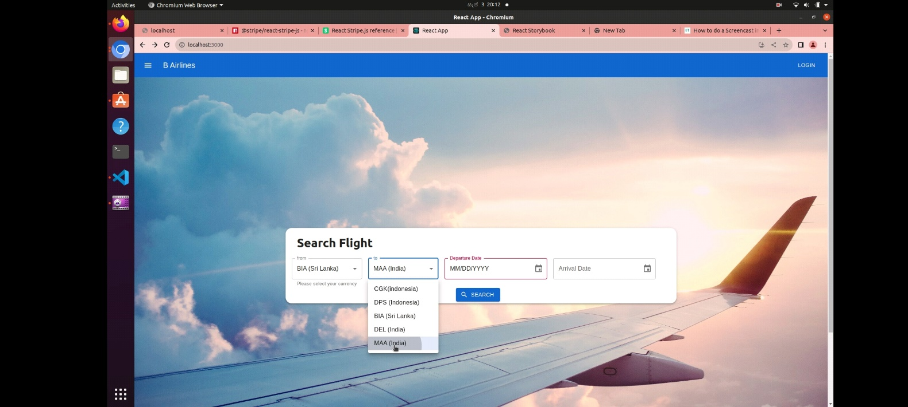

The user can select the origin and destination for flight as well as the dates for departure and arrival on this window. origin and destination components consist of drop-down lists containing the available airports from which the user must select one. Departure and Arrival components contain a calendar from which a date can be chosen. Once the above is completed the user can click the “SEARCH” button which exits this window and moves to the booking window.

### Flight Booking window

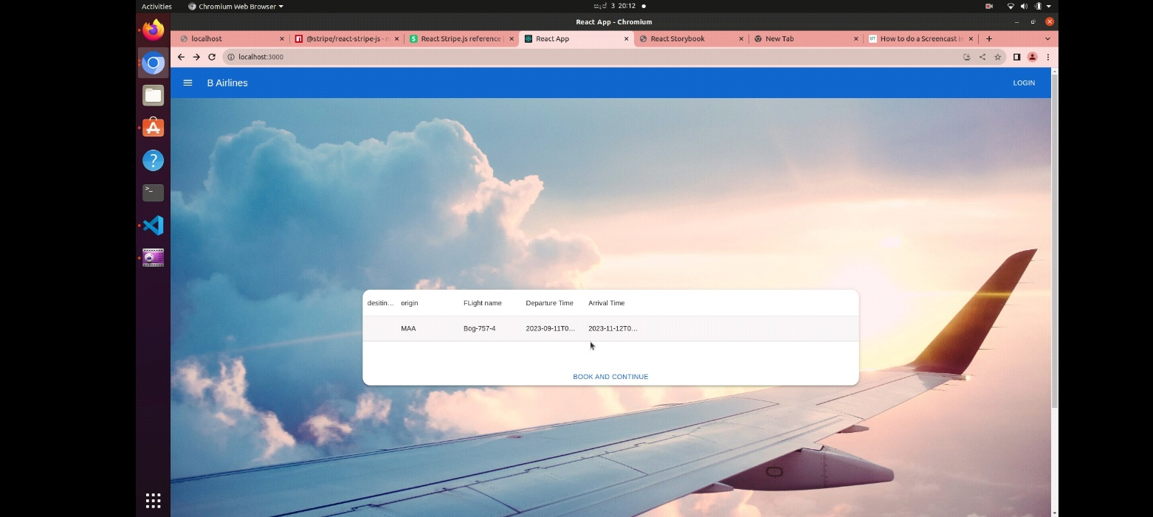

This page contains a list of available flights for the chosen criteria. The user can select one of them and click the “BOOK AND CONTINUE” link at the bottom to exit this window and move to passenger details window.

### Passenger Details collection window

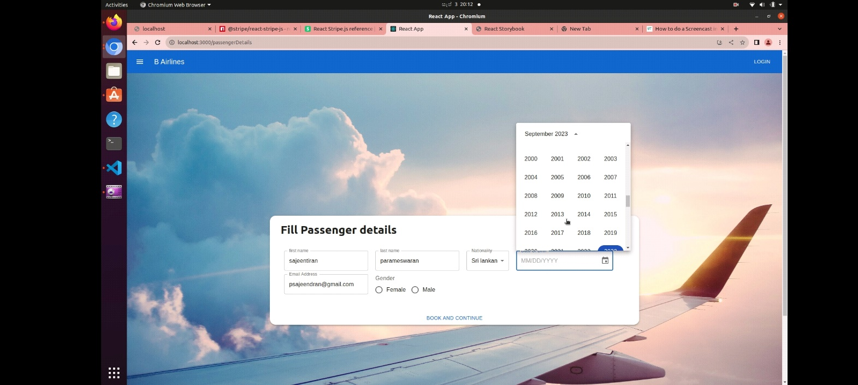

This page contains multiple GUI components from different families. There are text fields for the user to enter their first name, last name, and email address. There is a drop-down list to select nationality. A calendar component is also available for the user to enter date of birth. A radio button is also present for the user to enter their gender. Once all the above components are filled in by the user, they can exit this window and move to the seat selection window by clicking “BOOK AND CONTINUE” link at the bottom.

### Seat Selection

This page contains a 2-dimensionaal array of small “chair” icons to represent the seating inside the airplane. It’s broken into 3 groups as economy, business, and platinum. The user can click the chair icon in the position of user liking. Some icons will appear more transparent than the others. They represent the seats that have been already booked. The user cannot select them. Once the seat is selected the user can exit this window and move to the review and payment window by clicking “BOOK AND PROCEED TO REVIEW” link at the bottom.

### Review and Payment

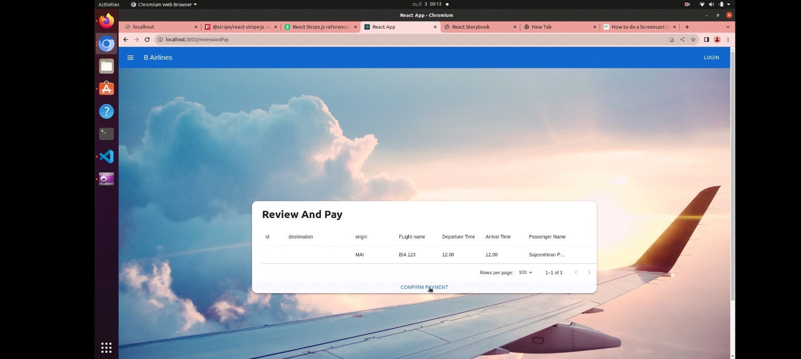

This page contains a list of bookings made by the user which are pending payment. The user can review the complete the booking by clicking “CONFIRM PAYMENT” link which will direct the user to the payment window.

### Confirmation

Once the payment is complete a confirmation message will be shown as a pop up on the current window. This completes the flight reservation.

## Hardware Interfaces

• Database server: The database server hardware should have sufficient storage capacity, processing power, and memory to handle the data volume and concurrent connections efficiently.

• Web server: The web server hardware should be capable of handling concurrent user connections and web traffic efficiently.

• User Devices (Client Computers and Mobile Devices): The software should be compatible with common operating systems (e.g., Windows, macOS, iOS, Android) and web browsers (e.g., Chrome, Firefox, Safari).

• Network infrastructure: The network infrastructure should provide reliable connectivity, high bandwidth, and security measures to protect data in transit.

• Communication Protocols: User devices will communicate with the web server over the internet using standard web communication protocols (HTTP/HTTPS).

## Software Interfaces

* Database interface: The system must interface with the airline's database to store and retrieve data. The database must be able to store data about flights, passengers, bookings, and other information.
* Operating system interface: The system must be able to run on the airline's operating system. The operating system must be able to support the features of the system, such as multithreading and networking.
* Web browser interface: The system must have a web-based user interface. The web browser must be able to display the system's pages and interact with the system's functions.
* Payment gateway interface: The system must interface with a payment gateway to process payments. The payment gateway must be able to accept payments from credit cards, debit cards, and other payment methods.
* Reporting tool interface: The system must interface with a reporting tool to generate reports. The reporting tool must be able to generate reports in a variety of formats, such as PDF, Excel, and CSV.

Given below are the data items that will be exchanged between the system and other software components:

* Flight data: This data includes the flight number, origin, destination, departure date, arrival date, and aircraft ID.
* Passenger data: This data includes the passenger's name, contact information, and other passenger details.
* Booking data: This data includes the flight number, passenger name, seat number, and payment information.
* Report data: This data includes the results of the system's reports, such as the number of passengers traveling to a given destination or the total revenue generated by each aircraft type.

## Communications Interfaces

Given below are the communications interfaces that the airline reservation system will have:

* E-mail interface: The system must be able to send and receive e-mails. The e-mails must be secure and must protect the privacy of users' data.
* Web browser interface: The system must have a web-based user interface. The web browser must be able to display the system's pages and interact with the system's functions.
* Network server communications protocols: The system must use standard network server communications protocols, such as HTTP and HTTPS. These protocols will ensure that the system can communicate with other systems securely.

Given below are the pertinent message formatting requirements:

* E-mail messages: The e-mails must be formatted in a standard way, such as HTML or plain text.
* Web pages: The web pages must be formatted in a standard way, such as HTML or CSS.
* Electronic forms: The electronic forms must be formatted in a standard way, such as XML or JSON.

Given below are the communication standards that the system will use:

* HTTP: The system will use HTTP to communicate with web browsers.
* HTTPS: The system will use HTTPS to communicate with web browsers when sensitive data is being transferred.
* FTP: The system may use FTP to transfer files to and from the airline's database.

Given below are the communication security / encryption issues:

* The system must use encryption to protect the privacy of data. The encryption must be strong enough to protect the data from unauthorized access.
* The system must be able to authenticate users. The authentication must be secure enough to prevent unauthorized users from accessing the system.
* The system must be able to detect and prevent attacks. The system must be able to detect and prevent attacks, such as denial-of-service attacks and malicious code attacks.

Given below are the data transfer rates and synchronization mechanisms:

* The system must be able to handle a high volume of data traffic. The system must be able to handle a high volume of data traffic, such as when many users are booking flights at the same time.
* The system must be able to synchronize data between different systems. The system must be able to synchronize data between different systems, such as the airline's database and the system's reporting tool.

# System Features

## Flight Search

### Description and Priority

The system must allow users to search for flights by origin, destination, departure date, and arrival date. The system must redirect to the page showing the results of the search in a list, with each result including the flight number, origin, destination, departure date, arrival date, aircraft type, and price.

Priority: High

Benefit: This feature will allow users to easily find the flights that they are looking for.

Penalty: If this feature is not implemented, users will have to find the flights that they are looking for manually, which can be time-consuming and difficult.

Cost: The cost of implementing this feature is moderate.

Risk: The risk of not implementing this feature is high. Users will be frustrated if they cannot easily find the flights that they are looking for.

The specific priority component ratings for this feature are as follows:

Benefit: 9 Penalty: 8 Cost: 5 Risk: 7

### Stimulus/Response Sequences

Stimulus: The user enters the origin, destination, departure date, and arrival date in the flight search form. The user clicks on the "SEARCH" button.

Response: The system redirects the user to the flight booking page.

### Functional Requirements

REQ-1: The system must allow users to enter the origin, destination, departure date, and arrival date in the flight search form.

The system must validate the input data to ensure that it is valid.

The system must display an error message if the input data is invalid.

REQ-2: The system must allow users to click on the "SEARCH" button to check flights.

The system must redirect the user to the flight booking page.

REQ-3: The system must handle anticipated error conditions and invalid inputs.

For example, if the user enters an invalid input in the flight search form, the system must display an error message and allow the user to correct the input.

If the system is unable to find any flights that match the user's search criteria, the system must display a message to that effect.

## Flight Booking

### Description and Priority

The system must allow users to book flights. The system must check the availability of seats and prices before booking a flight. The system must also allow users to select seats for their flights.

Priority: High

Benefit: This feature will allow users to easily book flights and guarantee their seats.

Penalty: If this feature is not implemented, users may not be able to book flights or may have to pay higher prices for seats.

Cost: The cost of implementing this feature is moderate.

Risk: The risk of not implementing this feature is high. Users will be frustrated if they cannot easily book flights or if they have to pay higher prices for seats.

The specific priority component ratings for this feature are as follows:

Benefit: 9 Penalty: 8 Cost: 5 Risk: 7

### Stimulus/Response Sequences

Stimulus: The user selects a flight in the flight search results and clicks “BOOK AND CONTINUE” link.

Response: The system redirects the user to the seat selection page.

### Functional Requirements

REQ-1: The system must allow users to select a flight in the flight search results.

The system must validate the input data to ensure that it is a valid flight.

The system must display an error message if the input data is invalid.

REQ-2: The system must allow users to click on the "BOOK AND CONTINUE" link to check the seating availability.

The system must redirect the user to the seat selection page.

REQ-3: The system must handle anticipated error conditions and invalid inputs.

For example, if the user enters an invalid input in the booking form, the system must display an error message and allow the user to correct the input.

If the seats are not available or the price is not acceptable, the system must display a message to that effect.

## Seat Selection

### Description and Priority

The system must allow users to select seats for their flights. The system must ensure that the seats that are selected are available.

Priority: Medium

Benefit: This feature will allow users to choose the seats that they want, such as window seats or aisle seats.

Penalty: If this feature is not implemented, users may not be able to select their preferred seats.

Cost: The cost of implementing this feature is low.

Risk: The risk of not implementing this feature is low. Users may be inconvenienced if they cannot select their preferred seats, but they will still be able to book flights.

The specific priority component ratings for this feature are as follows:

Benefit: 7 Penalty: 6 Cost: 2 Risk: 3

### Stimulus/Response Sequences

Stimulus: The user selects a seat.

Response: The system highlights the selected seat.

Stimulus: The user clicks “BOOK AND PROCEED TO REVIEW” link.

Response: The system redirects the user to review and payment page.

### Functional Requirements

REQ-1: The system must allow users to select seats for their flights.

The system must validate the input data to ensure that the seat is a valid seat.

The system must display an error message if the input data is invalid.

REQ-2: The system must highlight the selected seat.

The system must highlight the selected seat in a way that is easy for the user to see.

REQ-3: The system must check the availability of the selected seat.

The system must display a message if the seat is not available.

REQ-4: The system must allow users to change the selected seat.

The system must update the booking details to reflect the new seat selection.

REQ-5: The system must handle anticipated error conditions and invalid inputs.

For example, if the user selects an unavailable seat, the system must display an error message and allow the user to select a different seat.

If the seat selection is not available for the selected flight, the system must display a message to that effect.

## Payment

### Description and Priority

The system must allow users to make payments for their flights. The system must accept a variety of payment methods.

Priority: High

Benefit: This feature will allow users to easily pay for their flights and complete the booking process.

Penalty: If this feature is not implemented, users may not be able to pay for their flights and the booking process will be incomplete.

Cost: The cost of implementing this feature is moderate.

Risk: The risk of not implementing this feature is high. Users will be frustrated if they cannot pay for their flights and the booking process will be incomplete.

The specific priority component ratings for this feature are as follows:

Benefit: 9 Penalty: 8 Cost: 5 Risk: 7

### Stimulus/Response Sequences

Stimulus: The user selects a flight and clicks on the "Confirm Payment" link.

Response: The system redirects the user to the payment portal.

### Functional Requirements

REQ-1: The system must check the validity of the payment information to ensure that it is correct and belongs to the user.

The system must display an error message if the payment information is invalid.

REQ-2: If the payment information is valid, the system must book the flight and send a confirmation email to the user.

The system must send the confirmation email to the user's email address.

The confirmation email must include the booking details, such as the flight number, the seat number, and the price.

REQ-3: The system must handle anticipated error conditions and invalid inputs.

For example, if the user enters invalid payment information, the system must display an error message and allow the user to correct the information.

If the payment processor declines the payment, the system must display a message to that effect.

## User Registration / Login

### Description and Priority

The system must allow users to register for the system and log in to their accounts.

Priority: High

Benefit: This feature will allow users to create accounts and manage their bookings.

Penalty: If this feature is not implemented, users will not be able to create accounts or manage their bookings.

Cost: The cost of implementing this feature is moderate.

Risk: The risk of not implementing this feature is high. Users will be frustrated if they cannot create accounts or manage their bookings.

The specific priority component ratings for this feature are as follows:

Benefit: 9 Penalty: 8 Cost: 5 Risk: 7

### Stimulus/Response Sequences

Stimulus: The user clicks on the "Register" button.

Response: The system displays the registration form.

Stimulus: The user enters their username, email address, and password in the registration form.

Response: The system validates the user's input.

Stimulus: The user clicks on the "Submit" button.

Response: The system creates the user account and sends the user a confirmation email.

Stimulus: The user clicks on the "Login" button.

Response: The system displays the login form.

Stimulus: The user enters their username and password in the login form.

Response: The system validates the user's credentials.

Stimulus: The user clicks on the "Login" button.

Response: The system logs the user in and redirects them to the home page.

Stimulus: The user clicks on the "Forgot Password" link.

Response: The system sends the user a link to reset their password.

Stimulus: The user clicks on the link in the password reset email.

Response: The system displays the password reset form.

Stimulus: The user enters their new password in the password reset form.

Response: The system resets the user's password.

Stimulus: The user clicks on the "Submit" button.

Response: The system logs the user in with the new password.

### Functional Requirements

REQ-1: The system must allow users to create accounts.

The system must collect the following information from the user: Name, Email address, Password.

The system must store the user's information securely.

The system must not allow users to create duplicate accounts.

The system must not allow users to create accounts with invalid information.

REQ-2: The system must allow users to log in to their accounts.

The system must prompt the user to enter their email address and password.

The system must verify the user's credentials and allow them to log in if they are valid.

The system must not allow users to log in with invalid credentials.

The system must lock the user's account if they enter too many invalid credentials.

REQ-3: The system must allow users to reset their passwords.

The system must allow users to reset their passwords if they forget them.

The system must send the user a link to reset their password.

The system must allow users to reset their passwords even if their accounts are locked.

REQ-4: The system must handle anticipated error conditions and invalid inputs.

If the user enters invalid credentials, the system must display an error message and allow the user to try again.

If the user's account is locked due to too many failed login attempts, the system must allow the user to unlock their account.

If the user enters invalid information in the registration form, the system must display an error message and allow the user to correct the information.

## Report Delay

### Description and Priority

The system must allow users to report delays in their flights.

Priority: Medium

Benefit: This feature will allow users to be notified of delays in their flights and take steps to mitigate the impact of the delay.

Penalty: If this feature is not implemented, users may not be notified of delays in their flights and may experience inconvenience or financial loss.

Cost: The cost of implementing this feature is low.

Risk: The risk of not implementing this feature is low. Users can still contact the airline directly to inquire about delays.

The specific priority component ratings for this feature are as follows:

Benefit: 7 Penalty: 6 Cost: 2 Risk: 3

### Stimulus/Response Sequences

Stimulus: The airline staff sees that the flight is delayed.

Response: The system prompts the staff to report the delay.

Stimulus: The airline staff clicks on the "Report Delay" button.

Response: The system displays a form for the staff member to enter the information about the delay.

Stimulus: The staff member enters the information about the delay and clicks on the "Submit" button.

Response: The system sends a notification to the airline staff member that the delay has been reported.

Stimulus: The status of the delay changes.

Response: The system sends a notification to the passengers about the change in status with a report.

### Functional Requirements

REQ-1: The system must allow airline staff to report delays in their flights.

The system must allow users to enter the necessary information about the delay.

The system must send a notification to the airline staff when the delay is reported.

REQ-2: The system must allow passengers to track the status of reported delays.

The system must allow passengers to see the status of the reported delays:

The reason for the delay

The estimated time of departure or arrival

The system must send notifications to the passengers when the status of their reported delay changes.

REQ-3: The system must be able to store and retrieve reports of delays.

The system must be able to retrieve reports of delays by flight number, departure airport, arrival airport, or date and time.

REQ-4: The system must handle anticipated error conditions and invalid inputs.

If the user enters invalid information about the delay, the system must display an error message and allow the user to correct the information.

If the user reports a delay for a flight that does not exist, the system must display an error message and allow the user to try again.

## Report Generation

### Description and Priority

The system must allow users to generate reports on flight bookings, passenger demographics, and other data.

Priority: High

Benefit: This feature will allow airline administration to make better decisions about its operations, improve customer service, increase efficiency, and comply with regulations.

Penalty: If this feature is not implemented, airline administration will not be able to make informed decisions about its operations, improve customer service, increase efficiency, or comply with regulations.

Cost: The cost of implementing this feature is moderate.

Risk: The risk of not implementing this feature is high.

The specific priority component ratings for this feature are as follows:

Benefit: 9 Penalty: 8 Cost: 5 Risk: 7

### Stimulus/Response Sequences

Stimulus: The user logs into the system and clicks on the "Reports" tab.

Response: The system displays a list of available reports.

Stimulus: The user selects a report and clicks on the "Generate Report" button.

Response: The system prompts the user to select the criteria for the report.

Stimulus: The user selects the criteria and clicks on the "Generate Report" button.

Response: The system generates the report and displays it to the user.

### Functional Requirements

REQ-1: The system must allow users to generate reports on flight bookings, passenger demographics, and other data.

The system must provide a list of available reports.

The system must allow users to select the criteria for the report.

The system must generate the report and display it to the user.

The system must allow users to save the report to their computer or share it with others.

REQ-2: The system must be secure.

The system must protect the confidentiality of the data used to generate the reports.

The system must protect the integrity of the reports.

The system must be available to users when they need it.

REQ-3: The system must handle anticipated error conditions and invalid inputs.

If the user selects an invalid report, the system must display an error message and allow the user to select a different report.

If the user enters invalid criteria for the report, the system must display an error message and allow the user to correct the criteria.

If the system is unable to generate the report, the system must display an error message and explain why the report could not be generated.

# Other Nonfunctional requirements

## Performance Requirements

### Flight Schedule Retrieval

* The system should retrieve and display flight schedules for a given day within 2 seconds of the user's request.
* The system must handle multiple users concurrently requesting flight schedules without significant performance degradation.

### Seat Selection

* + The system should display seat selection options to the user within 1 second after the user selects a flight.
  + The system should ensure that seat selection is completed by the user within 5 minutes to avoid reservation conflicts.

### Passenger Booking

* + The system must create a booking and allocate a seat within 3 seconds of the user's confirmation.
  + The system shall support concurrent booking operations by multiple users without conflicts.
  + During peak hours, the system should manage a minimum of 100 booking transactions per second.

### Reports Generation

* + The system shall generate reports, such as passenger lists and revenue reports, within 10 seconds of the user's request.
  + The system shall ensure that report generation does not affect the responsiveness of other system functions.

### Database Scalability

* The database must be designed to accommodate the addition of new airports and destinations.
* The system shall support at least 50% growth in airport and destination data within a year without significant performance degradation.

### System dependability

* If the software loses the connection to the Internet, the user should be informed by the system with a “Data could not be retrieved as there is an error occur in data connection.” message.
* Else if the system gets some strange input, the system will be able to display an incorrect password message to the user.

### Reduce data redundancy

- It will have a perfect collection of data information where no duplicates of data.

## Safety Requirements

### Data Security

* The system should guarantee that passenger and payment information is securely stored and protected from unauthorized access.
* The system shall comply with relevant data protection laws and regulations to safeguard passenger data.

### User Authentication

* The system shall implement robust user authentication mechanisms to prevent unauthorized access to booking and payment functions.
* User passwords shall be securely encoded and stored in the database.

## Security Requirements

### Access Control

* The system shall implement role-based access control to restrict access to sensitive functionalities based on user roles, such as administrators, staff, and passengers.

### Encryption

* The system shall use encryption protocols, such as HTTPS, to secure data transmission between the user's device and the server.

### Audit Trail

* The system shall maintain an audit trail of user actions, including login attempts, booking changes, and payment transactions, for security and accountability purposes.

## Software Quality Attributes

### Reliability

* The system shall have a system uptime of at least 99.9% to ensure continuous availability to users.

### Maintainability

* The system shall be designed with modular and well-documented code to facilitate future updates and maintenance.

### Usability

* The user interface shall be intuitive and user-friendly to ensure ease of use by passengers and staff.

## Business Rules

### Booking Restrictions

* Passengers cannot select the same seat on a flight.
* The system shall prevent overbooking of seats.

### User Discounts

* Registered users shall be categorized as Frequent or Gold based on their booking history.
* Frequent users shall receive a 5% discount on ticket prices, while gold users shall receive a 9% discount.

# Other Requirements

## Database Requirements

### Database Management System

* The ARS will use the MySQL relational DBMS.

### Database Schema

* The database of the ARS will store information such as passenger details, flight details, aircraft and ticket details etc. using tables with properly defined relationships among them.

## Generalization Requirements

### Language

* English is the only language supported by the ARS.

### Date/Time

* Date and Time formats in the ARS will follow the international standards.

## Legalization Requirements

### Copyrights

* Everything displayed on the web and used in the ARS will include proper copyright notices and terms of use.

### Privacy of data

* The ARS will only collect the data that is required to use the system.
* Collected data will be secured using necessary protocols.

# Appendix A: Glossary

The table below defines all the terms necessary to properly interpret the SRS, including acronyms and abbreviations.

|  |  |
| --- | --- |
| **Acronym/Abbreviations** | **Definition** |
| SRS | Software Requirements Specification |
| ARS | Airline Reservation System |
| HTTP | HyperText Transfer Protocol |
| HTTPS | HyperText Transfer Protocol Secure |
| XML | eXtensible Markup Language |
| FTP | File Transfer Protocol |
| TBD | To Be Determined |
| ER Diagram | Entity Relationship Diagram |
| DBMS | Database Management System |

# Appendix B: Analysis Models

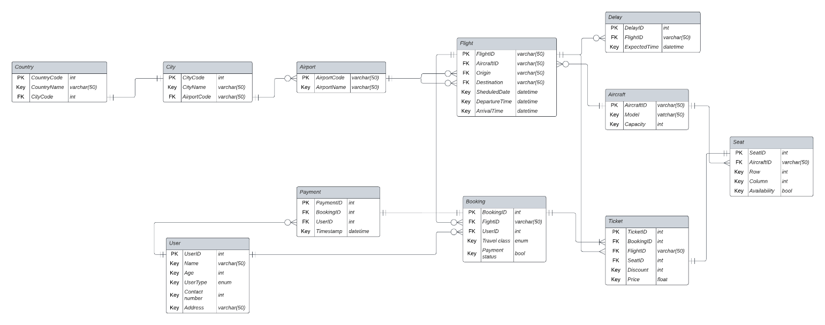

# Appendix C: To Be Determined List

* The payment platform for the bookings haven’t been determined as of the writing. Therefore, the implementation of system feature 4.4 is TBD.
* There are other features such as customer ratings and feedback which are to be included in the ARS.
* Another feature is the booking cancellation feature which should be included in the web application. This feature is also TBD.
* We could be adding more privacy and security features into the web application as well as the database which hasn’t been developed yet.